The Process of Starting a Java-Based Web Application
- First of all, you need to package your application.
- Choose which type of web servers you want to use and download it. They are lot of different solutions out there.
- You need to configure that specific web server.
- After that, you must organize the deployment process and start your web server.
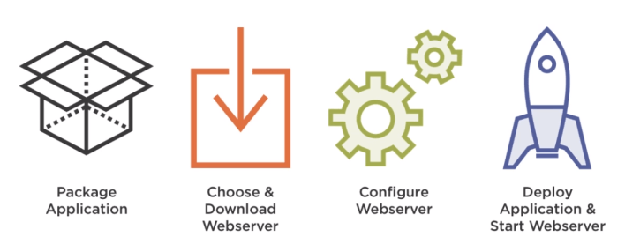
With Spring Boot, you need the following process:
- Package your application
- Run it with some simple command like java -jar my-application.jar
Really, it's that simple.
Spring Boot takes care of the rest by starting and configuring an embedded web server and deploys your application there.

